E-RESOURCES FOR COMIC BOOKS AND GRAPHIC NOVELS AT ELIBRARYUSA
--Ebrary--
Web Comics for Teens
Duggan, Michael
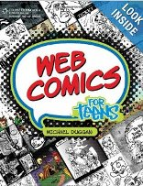
Are you always doodling heroes and villains for your own comic adventures? Have you ever imagined creating your own comic book for others to read? With "Web Comics for Teens", you can! "Web Comics for Teens" introduces you to the skills, tools, and programs you need to create your own web comics, comics, and cartoons published on the World Wide Web.

Combining the Worlds of Contemporary Comics. Singer, Marc.

One of the most eclectic and distinctive writers currently working in comics, Grant Morrison (brings the auteurist sensibility of alternative comics and graphic novels to the popular genres-superhero, science fiction, and fantasy-that dominate the American and British comics industries. His comics range from bestsellers featuring the most universally recognized superhero franchises (All-Star Superman, New X-Men) to more independent, creator-owned work (The Invisibles) that defies any generic classification.
Demanding Respect: The Evolution of the American Comic Book
Lopes, Paul
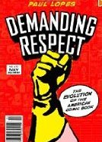
How is it that comic books—the once reviled form of lowbrow popular culture—are now the rage for Hollywood blockbusters, the basis for bestselling video games, and the inspiration for literary graphic novels? In Demanding Respect, Lopes immerses himself in the discourse and practices of this art and subculture to provide a social history of the American comic book over the last 75 years.
Hand of Fire: The Comics Art of Jack Kirby. Hatfield, Charles.
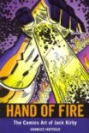
Jack Kirby (1917-1994) is one of the most influential and popular artists in comics history. With Stan Lee, he created the Fantastic Four and defined the drawing and narrative style of Marvel Comics from the 1960s to the present day. Kirby is credited with creating or cocreating a number of Marvel's mainstay properties, among them the X-Men, the Hulk, Thor, and the Silver Surfer. His earlier work led to the creation of Captain America, the popular kid gang and romance comic genres, and one of the most successful comics studios of the 1940s and 1950s.
Discover manga drawing 30 easy lessons for drawing guys and girls. Galea, Mario.
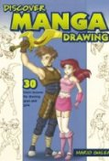
Manga has become one of the most popular types of comic-book art, with more and more fans looking to draw in this style. The beginning manga artists will find everything they need in this easy-to-follow book, including: 30 essential demos covering all of the basics, such as facial features, body structure and characters, all of which can be completed with nothing but a pencil; Projects arranged using a progressive approach -- readers first learn how to draw basic bodies, then move on to clothing, props and poses.
Comics as Philosophy.McLaughlin, Jeff (Editor).
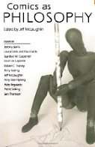
Through the combination of text and images, comic books offer a unique opportunity to explore deep questions about aesthetics, ethics, and epistemology in non-traditional ways. The essays in this collection focus on a wide variety of genres, from mainstream superhero comics, to graphic novels that exercise social realism, to European adventure classics.

The Superhero Book: The Ultimate Encyclopedia of Comic-Book Icons and Hollywood Heroes. Misiroglu, Gina.
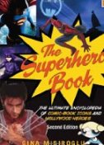
Appealing to the casual comic book reader as well as the hardcore graphic novel fan, this ultimate A-to-Z compendium describes everyone’s favorite participants in the eternal battle between good and evil. With nearly 200 entries examining more than 1,000 icons and their place in popular culture, it is the first comprehensive profile of superheroes across all media, following their path from comic book stardom to radio, television, movies, and novels.

--Gale Virtual Reference Library--
The Rough Guide to Manga. Yadao, Jason.
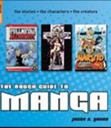
Features the manga story (a Japanese style of comic books) covering manga's twelfth-century roots to the rise of English-language manga with profiles of influential creators like Leiji Matsumoto and CLAMP.

